Using Rubrics

Using a rubric for assessing writing can greatly reduce the amount of time spent commenting on and grading papers. Rubrics also highlight the objective criteria used in evaluating papers and may be helpful to students as they prepare and draft their papers. There are many kinds of rubrics or grade sheets you may want to consider. Common features include:
- Desired features are categorized and described
- Categories are ranked or shown in a hierarchy
- Language and criteria should be based on how the assignment is described on the assignment sheet and discussed in class
- Rubrics should always be presented and discussed with the class before being used. This helps the students understand the expectations and gives an opportunity for them to ask for clarification of expectations.

Categories vary according to the assignment, but the following are fairly common:
- content (depth of coverage, thoroughness of development, quality of argument)
- organization and coherence
- readability
- mechanical and grammatical correctness

To provide the most valuable feedback for your students, a rubric should be used in conjunction with a summary comment addressing specific features of the individual paper.

There are different kinds of rubrics to consider using. The most common rubrics are holistic, analytic or single point. There are advantages and disadvantages to each of them. Here is a helpful website that breaks down the different kinds of rubrics with examples.

When using Blackboard as your primary grading tool, it may be easiest to opt for either an analytic rubric or a point-based grade sheet. Here are examples of these two options.

Analytic Rubric
An analytic rubric is usually designed as a grid with criteria for the student on the left and the levels of ability provided across the top. The different levels area usually represented with numbers or a descriptor (developing, proficient, mastery, etc.). Instructors can use the language within the cells to provide feedback to the student on each category as well as an aide to their own assessment and determining a fair grade. The instructor is then free to determine the grade based on the levels the student writer achieved in the different categories.

Example:
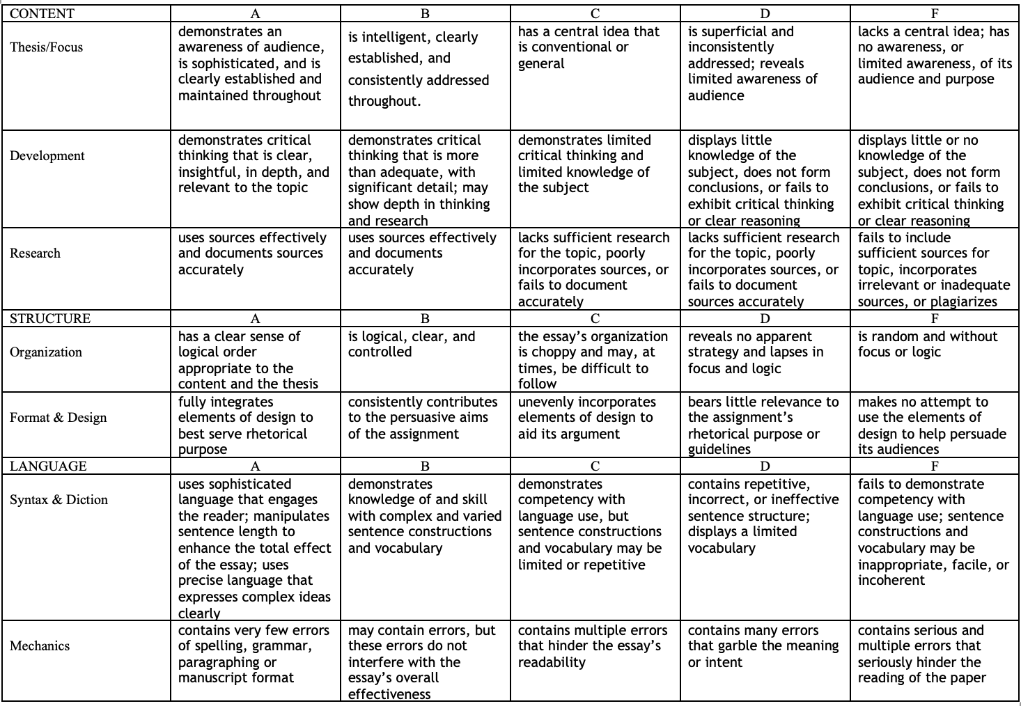

Grade sheet
Many instructors use grade sheets rather than rubrics. Grade sheets differ in that they place a point value on the different categories determining the grade. Grade sheets can be especially helpful if you find yourself struggling to give constructive feedback or accurate grades. Point values (out of the points you want to assign the essay) are divided into categories, with higher point values given to categories that carry more weight (thesis, argument, organization), and lower point values are given to categories that are of minor concern (diction, grammar, etc).

Example:
